K-5 CCSS & Smarter Balanced Mathematics
Key Shifts to Claims

Presenter:
Brian Graham, TOSA
Camas School District
Brian.graham@camas.wednet.edu

Contrasting the Claims
Instructions: Individually review the items below that have been written for 4.OA below. Review them with a partner by claim number. Be prepared to respond to the following questions:

1. What are the differences in the way the problems are written by claim?
2. How does the focus on the four claims change the way you instruct and assess students in the classroom?

Claim 1: Examples
Grade 4 – 4.OA
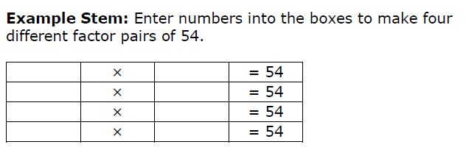

Grade 4, 4.OA
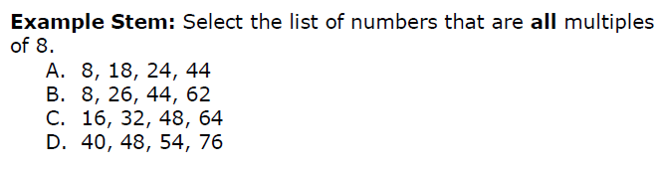

Grade 4, 4.OA
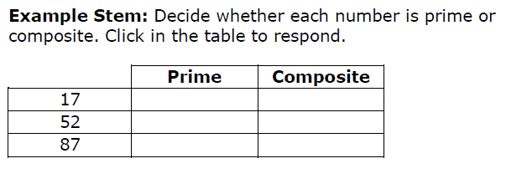

Grade 4, 4.OA
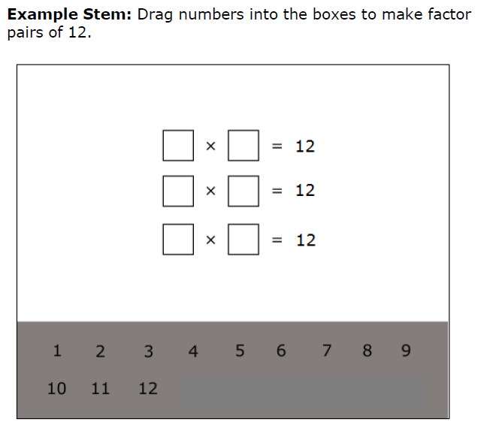

Claim 2: Examples
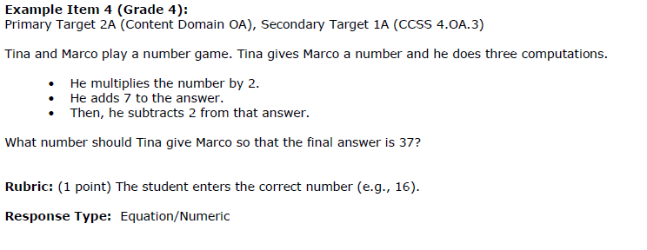

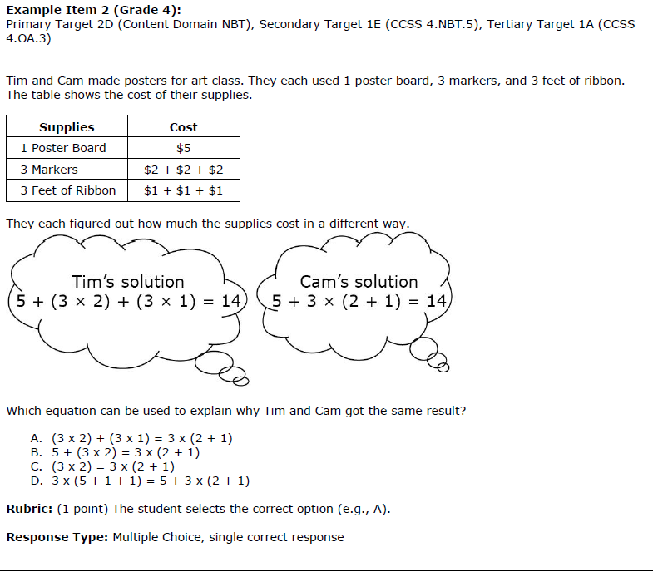

Claim 3 Examples
Grade 4, 4.OA
Joe and Sally make 72 cookies for a bake sale. They will put an equal number of cookies into bags. Joe and Sally want to put more than 2 cookies but fewer than 10 cookies into each bag.
Sally says they can only put 8 cookies into 9 bags or 9 cookies into 8 bags.
Joe thinks there are more ways to put an equal number of cookies into bags.
Explain why Joe is correct or incorrect.

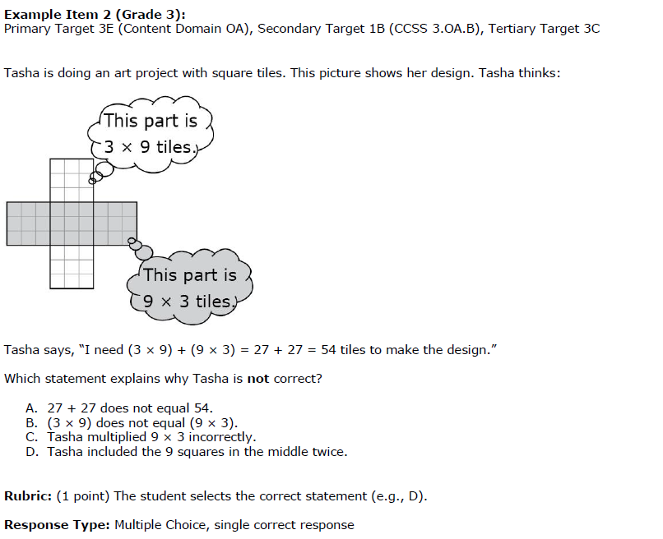

Claim 4 Examples
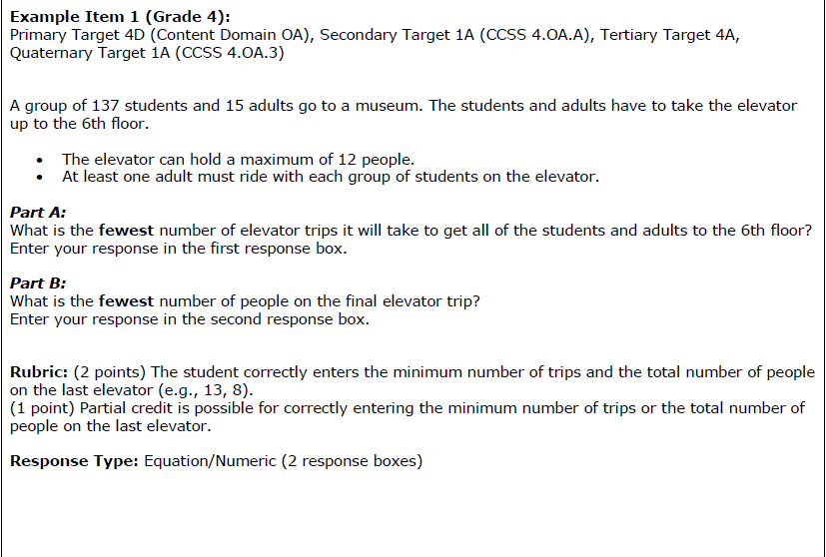

Item Types Activity
Review the ‘Item Type’ worksheet and talk to a partner about these questions. Be prepared to share your discussion:
- What implications do these item types have, if any, on your instruction and assessment of students?
- What resources do you have that might allow you to create similar items and imbed them in instruction and assessment?
Multiple Choice – multiple correct responses (3rd grade)
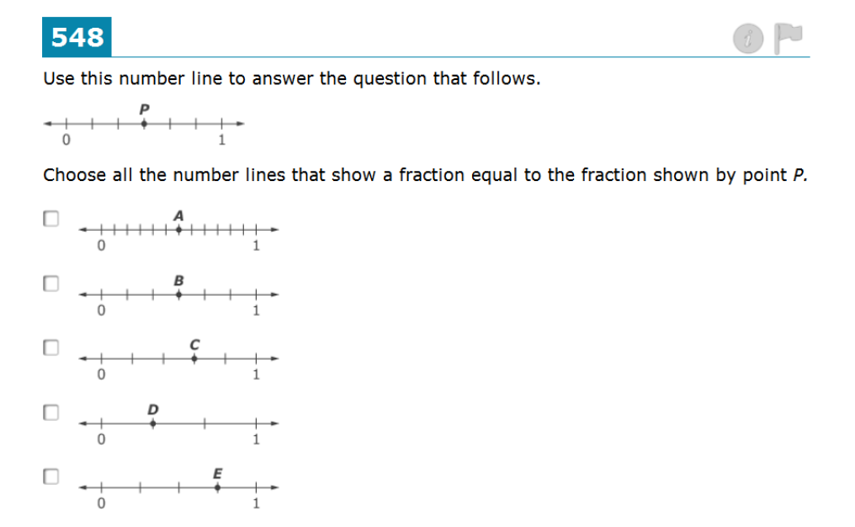
Multiple Choice – single correct response (5th grade)
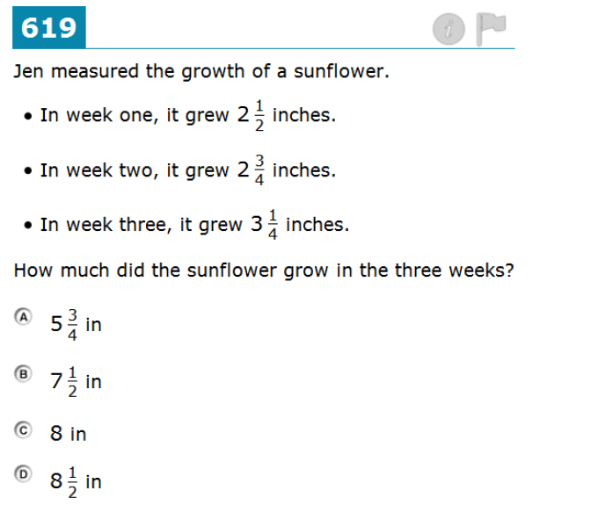

Equation/Numeric (3rd grade)
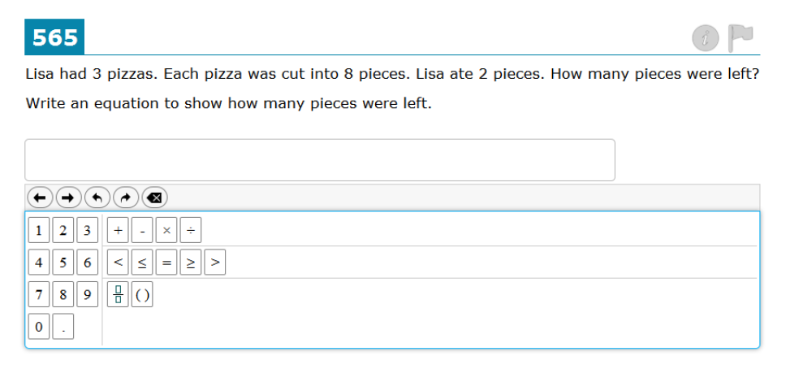

Equation/Numeric (4th grade)
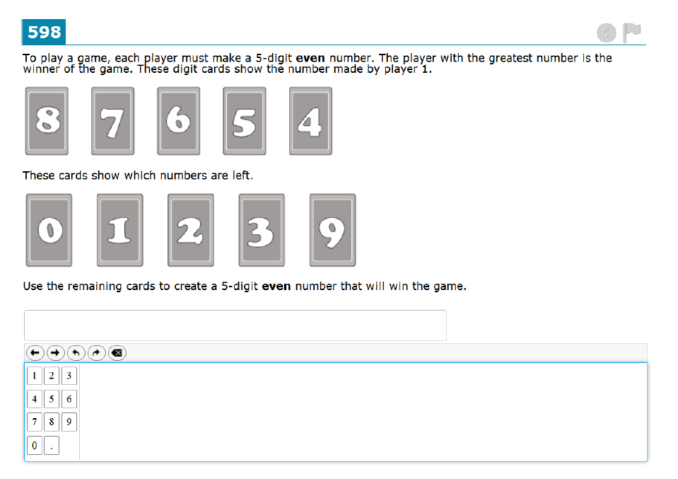

Drag & Drop (bottom bar) (5th grade)
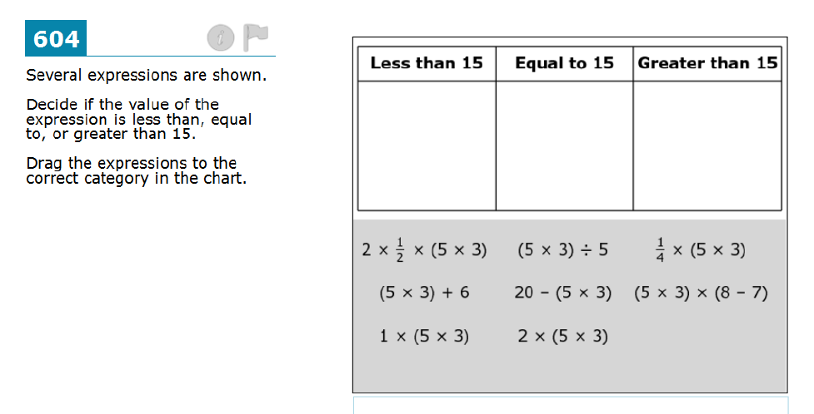

Drag and Drop (side bar) (3rd grade)
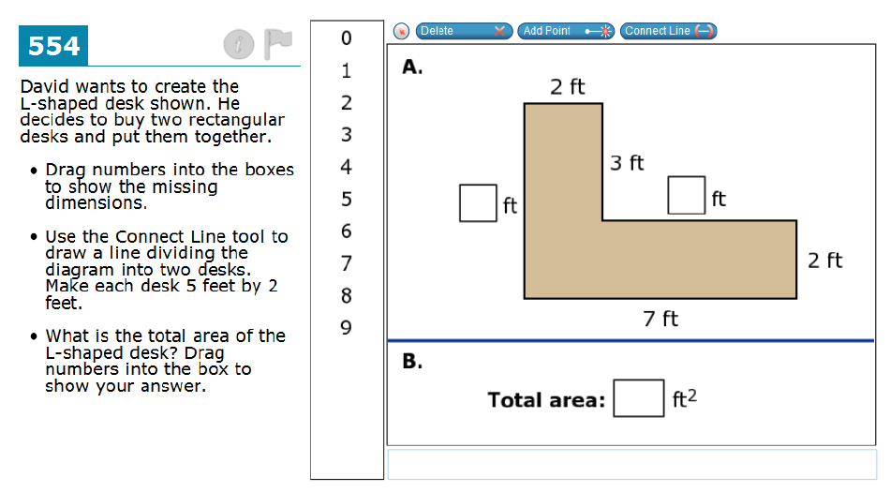

Graphing (4th grade)
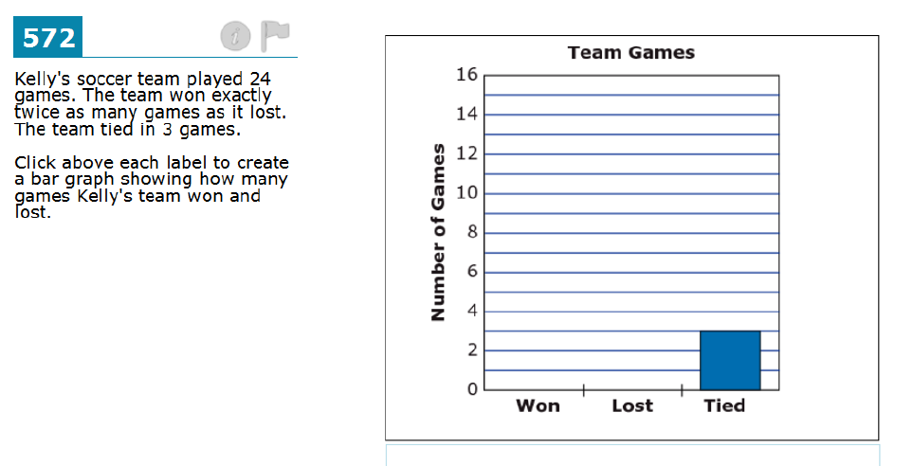

Graphing (5th grade)
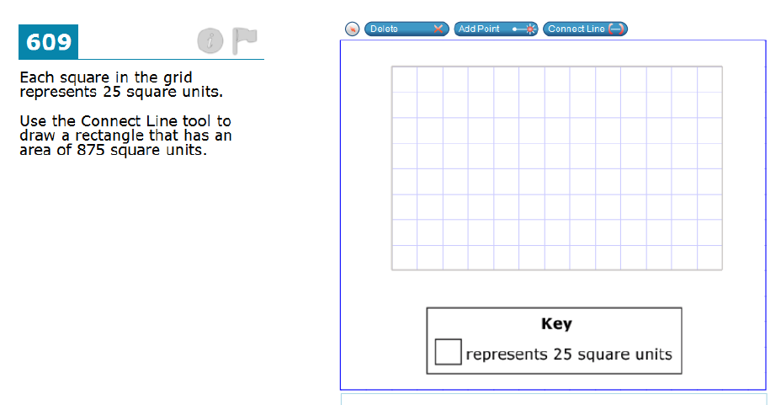

Fill in Table (5th grade)
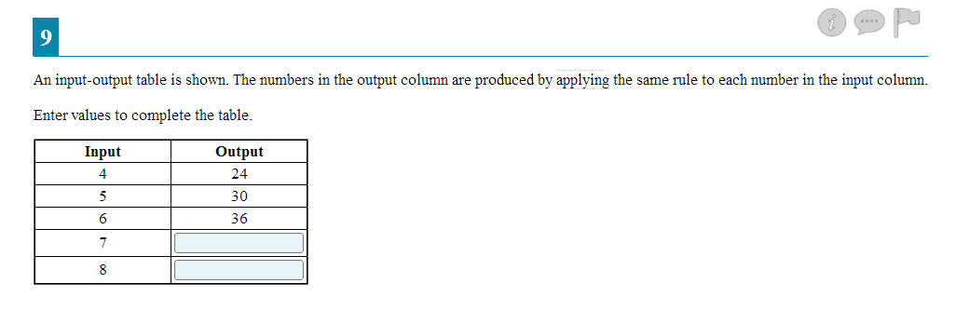

Matching Table (4th grade)
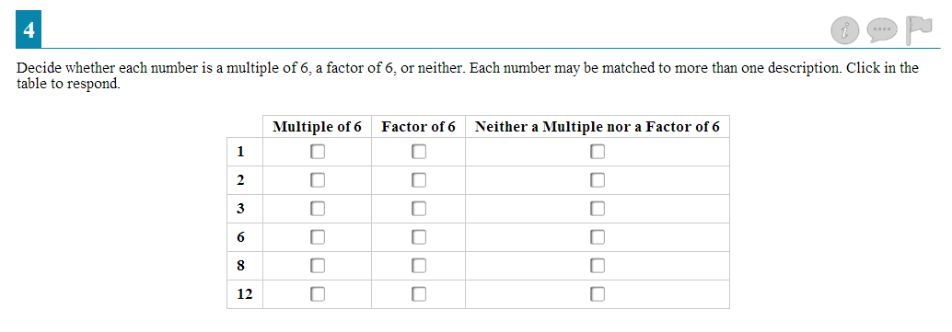

Hot Spot (3rd grade)
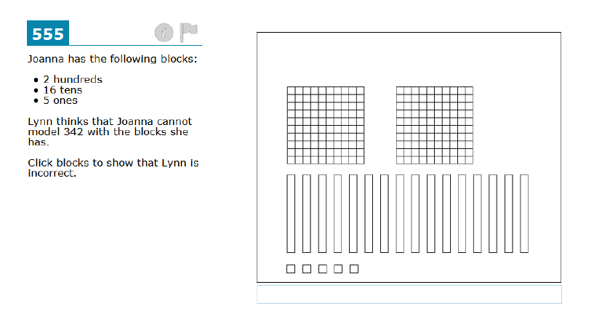

Hot Spot (4th grade)
