6-12 CCSS & Smarter Balanced Mathematics
Key Shifts to Claims

Presenter:
Brian Graham, TOSA
Camas School District
Brian.graham@camas.wednet.edu

Contrasting the Claims-Middle School-Expressions and Equations
Instructions: Individually review the items below that have been written for the middle school domain Expressions and Equations. Review them with a partner by claim number. Be prepared to respond to the following questions:

1. What are the differences in the way the problems are written by claim?
2. How does the focus on the four claims change the way you instruct and assess students in the classroom?
Claim 1: Examples
6th
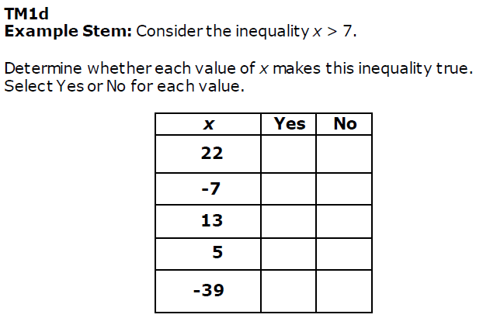

7th
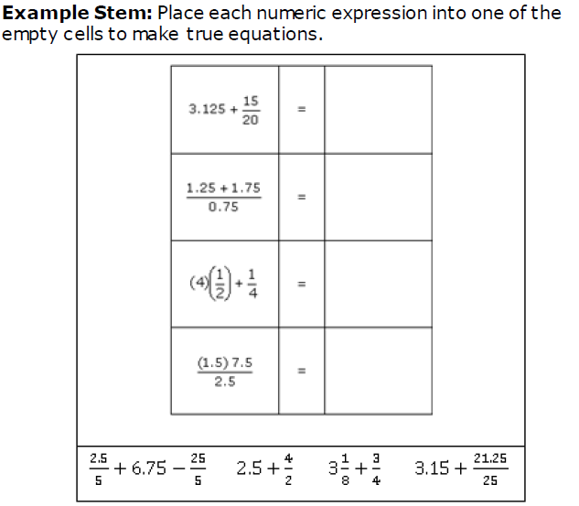

8th
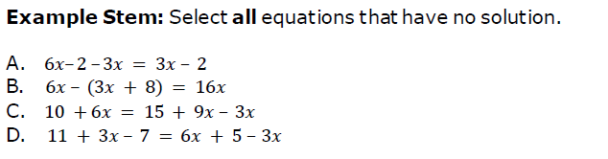

Claim 2: Examples
6th
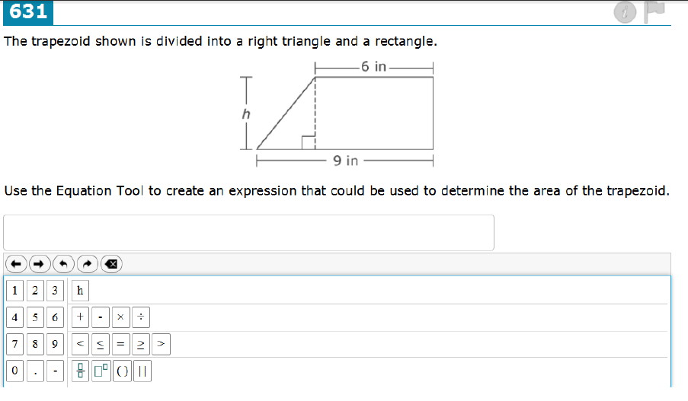

7th
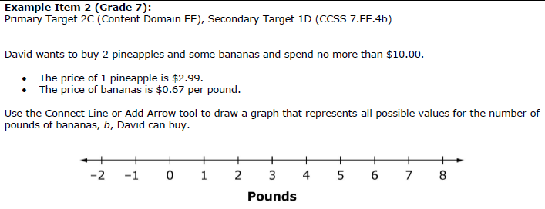

8th
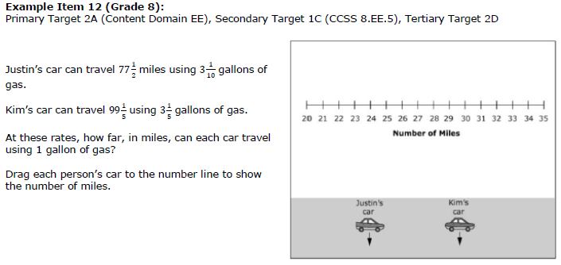

Claim 3 Examples
6th
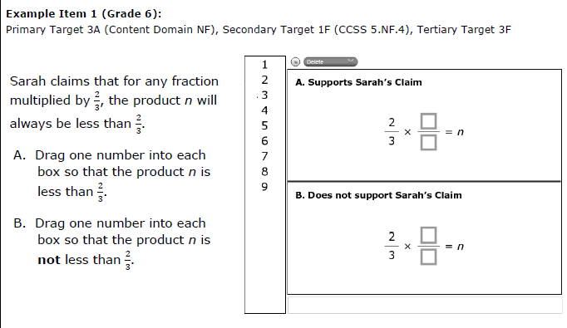

7th
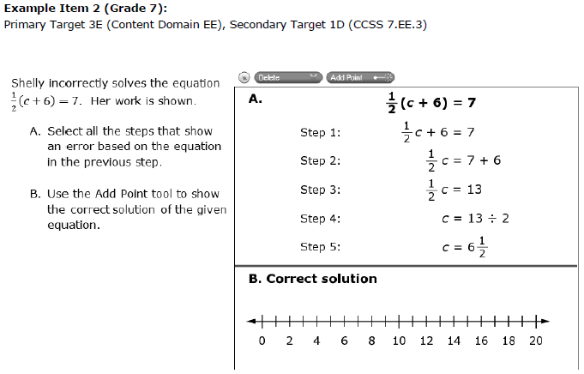

8th ( We couldn’t find a Task Model for Claim 3 directly aligned with 8th grade EE)
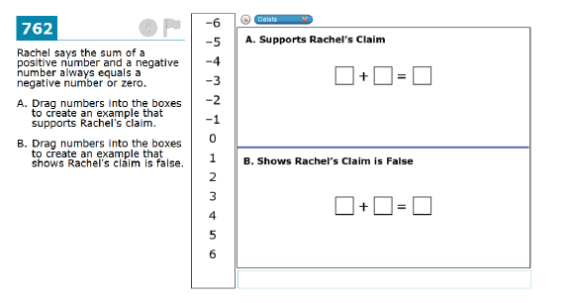

Claim 4 Examples
6th
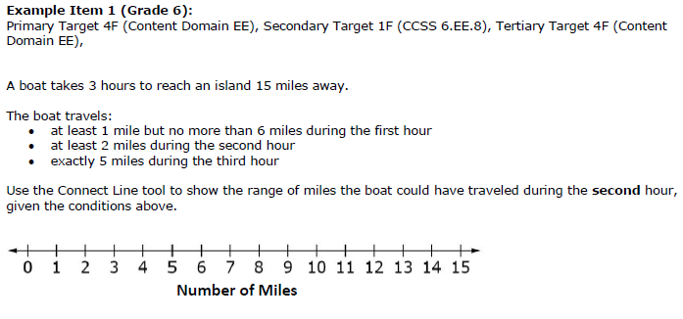
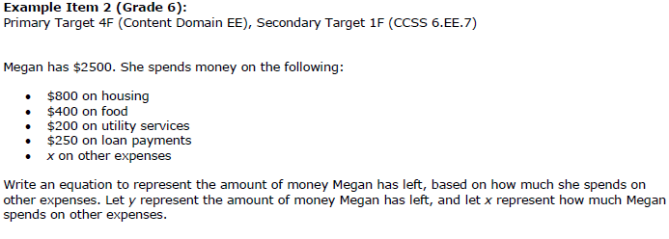

7th ( We couldn’t find a Task Model for Claim 4 directly aligned with 7th grade EE)
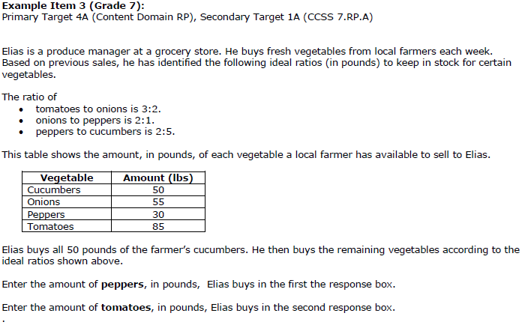

8th
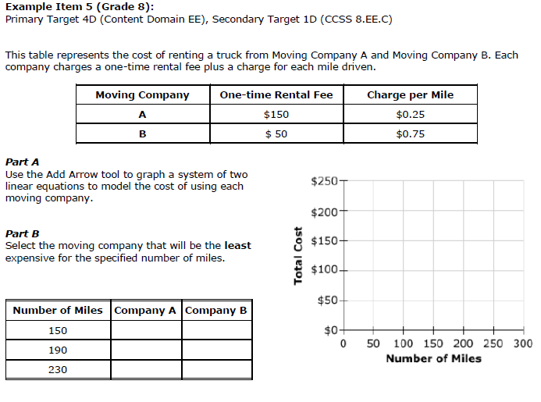

Contrasting the Claims-HS-Functions
Instructions: Individually review the items below that have been written for the domain high school Functions. Review them with a partner by claim number. Be prepared to respond to the following questions:

1. What are the differences in the way the problems are written by claim?
2. How does the focus on the four claims change the way you instruct and assess students in the classroom?

Claim 1: Examples
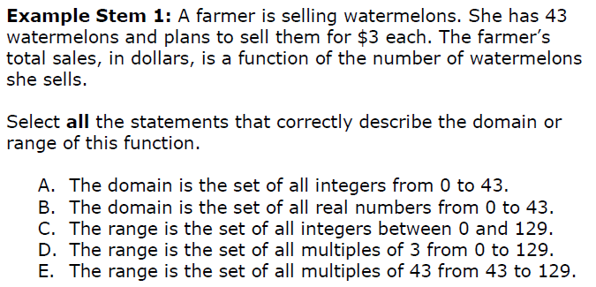

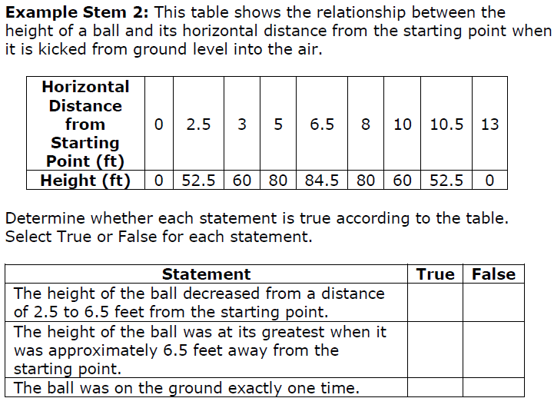

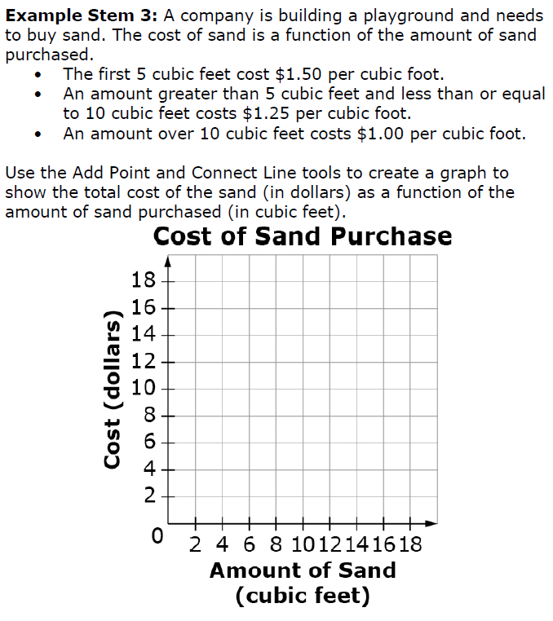

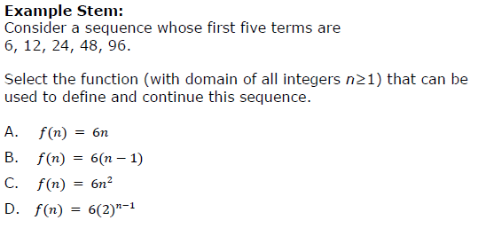

Claim 2: Examples
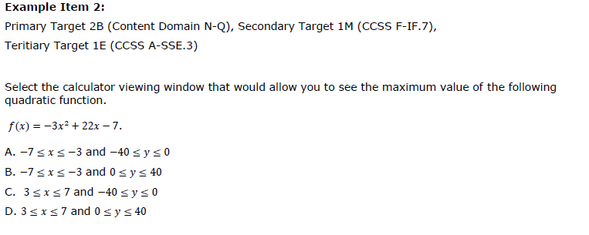

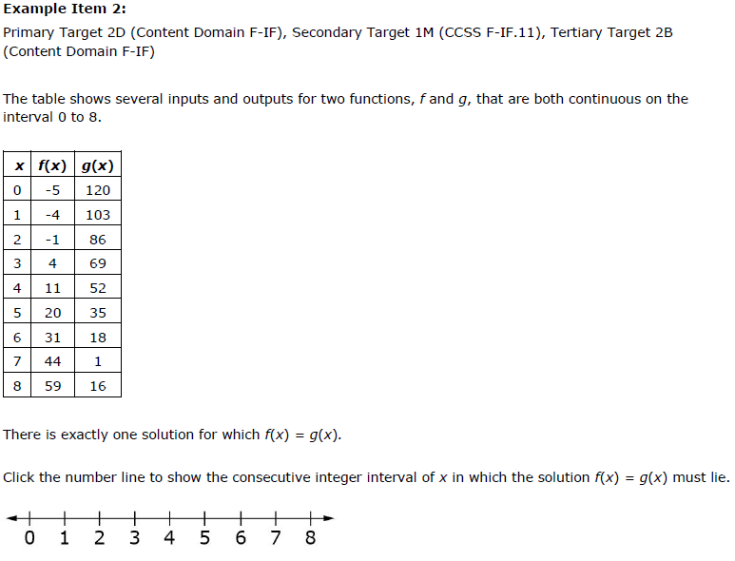

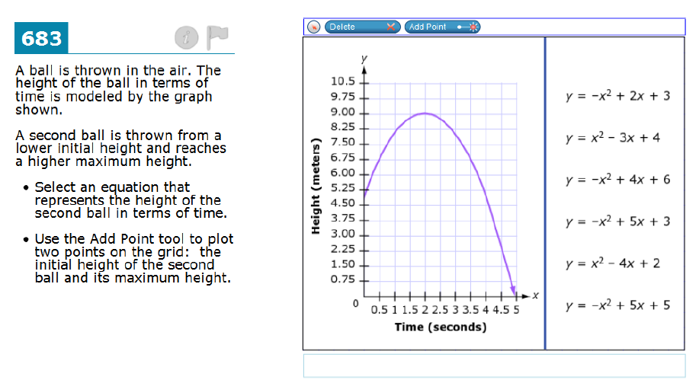

Claim 3 Examples
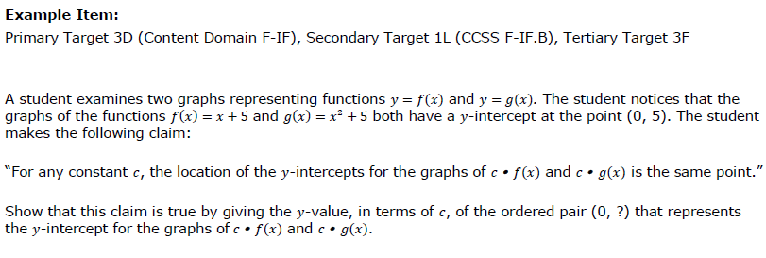

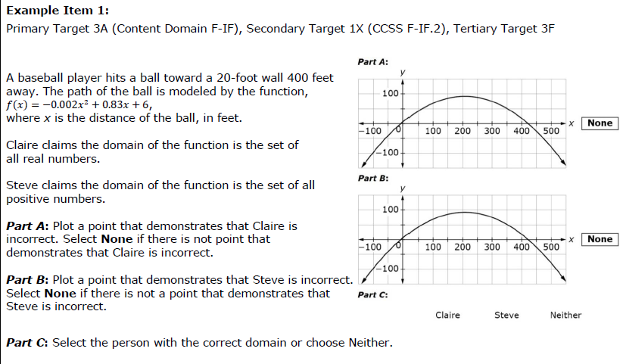

Claim 4 Examples
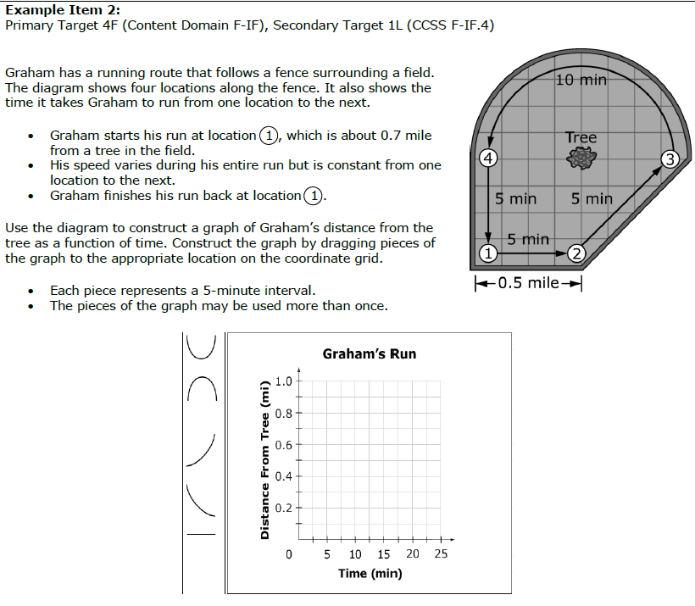

Item Types Activity – Middle School & High School
Review the ‘Item Type’ worksheet and talk to a partner about these questions. Be prepared to share your discussion:
- What implications do these item types have, if any, on your instruction and assessment of students?
- What resources do you have that might allow you to create similar items and imbed them in instruction and assessment?
Multiple Choice – single correct response (7th grade)
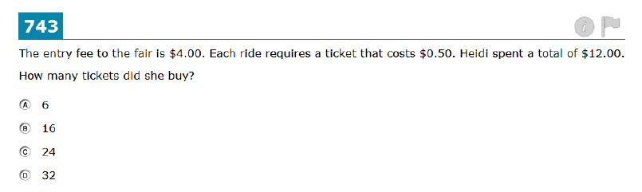

Multiple Choice – multiple correct responses (7th grade)
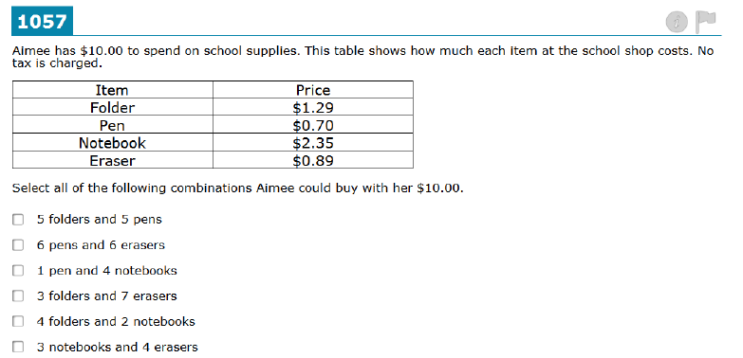

Equation/Numeric (6th grade)
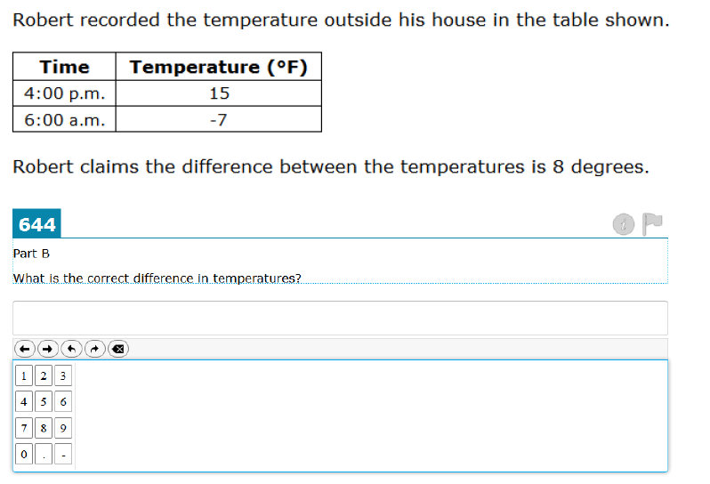

Equation/Numeric (HS)
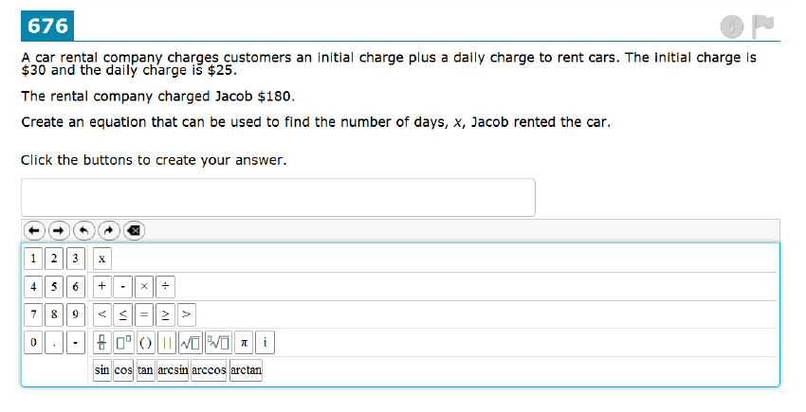

Drag & Drop (bottom bar) (6th grade)
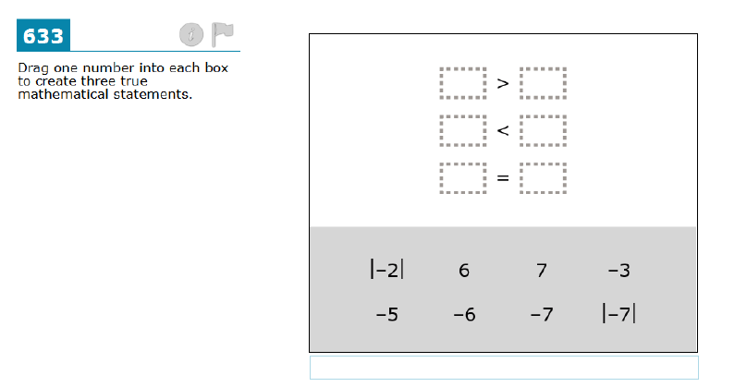

Drag and Drop (side bar) (HS)
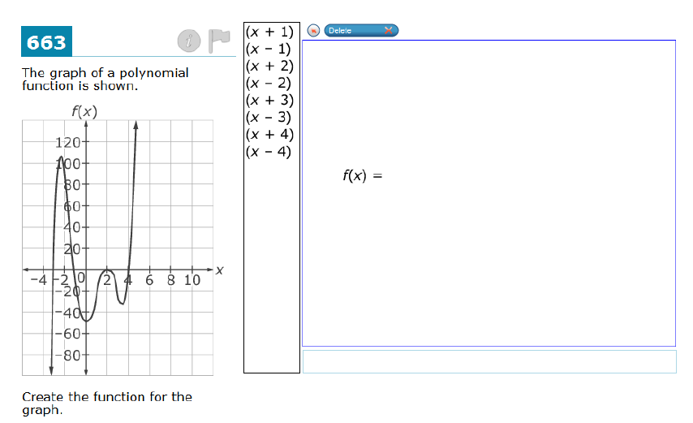

Graphing (8th grade)
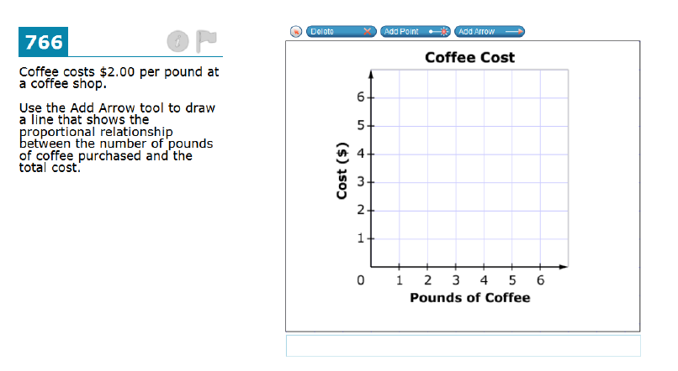

Graphing (HS)
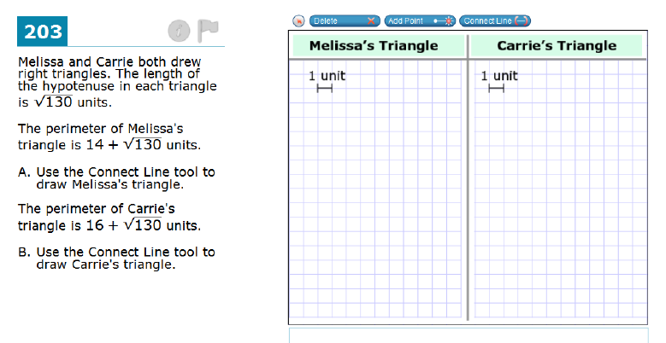

Fill in Table (7th grade)
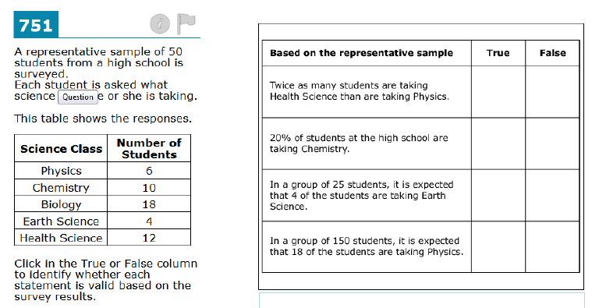

Fill in Table (HS)
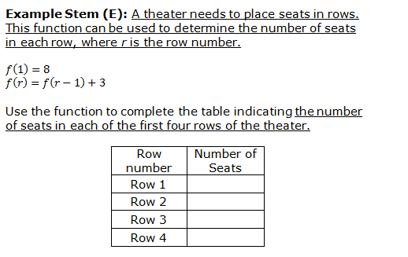

Matching Table (HS)
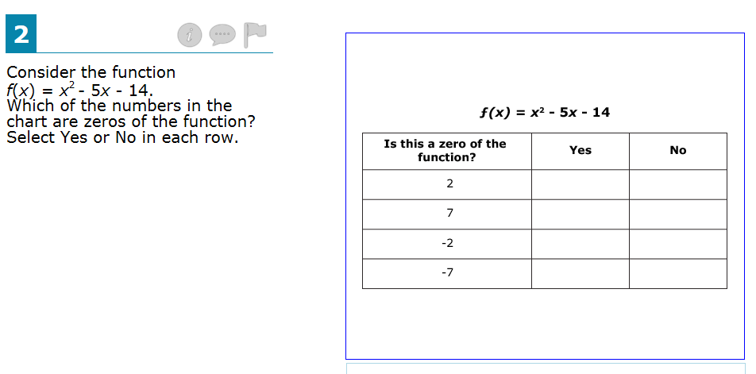

Hot Spot (HS)
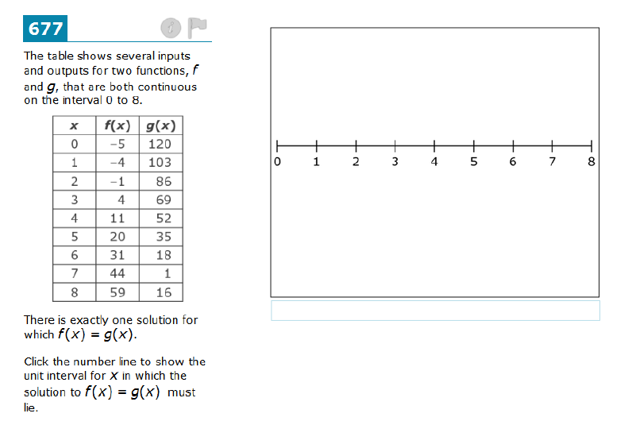

Hot Spot (6th grade)
